Supplement Utilization among Poststroke Patients at Physical Medicine and Rehabilitation Clinic Dr. Hasan Sadikin General Hospital Bandung from June−November 2013

Annisa Rahayu,¹ Novitri,² Novi Vicahyani Utami³

¹Faculty of Medicine, Universitas Padjadjaran, ²Department of Physical Medicine and Rehabilitation, Faculty of Medicine, Universitas Padjadjaran/Dr. Hasan Sadikin General Hospital, Bandung ³Department of Pharmacology, Faculty of Medicine, Universitas Padjadjaran, Indonesia

- Annisa Rahayu
Faculty of Medicine, Universitas Padjadjaran
Jalan Raya Bandung – Sumedang Km. 21
Jatinangor, Sumedang, West Java, Indonesia
Phone: +62 85692641930
Email: annisarahayuannisa@gmail.com

- Novitri, dr., SpKFR
Department of Physical Medicine and Rehabilitation, Faculty of Medicine, Universitas Padjadjaran/Dr. Hasan Sadikin General Hospital
Jalan Pasteur No. 38, Bandung 40161, Indonesia
Phone: +62 8156005071
Email: novitris@gmail.com

- Novi Vicahyani Utami, dr., M.Kes
Department of Pharmacology, Faculty of Medicine, Universitas Padjadjaran
Jalan Prof. Eyckman No. 38, Bandung 40161, Indonesia
Phone: +62 8122122979
Email: novi.farmakologi@gmail.com

Supplement Utilization among Poststroke Patients at Physical Medicine and Rehabilitation Clinic Dr. Hasan Sadikin General Hospital Bandung from June−November 2013

Annisa Rahayu,¹ Novitri,² Novi Vicahyani Utami³

¹Faculty of Medicine, Universitas Padjadjaran, ²Department of Physical Medicine and Rehabilitation, Faculty of Medicine, Universitas Padjadjaran/Dr. Hasan Sadikin General Hospital, Bandung ³Department of Pharmacology, Faculty of Medicine, Universitas Padjadjaran, Indonesia

Abstract

Background: Stroke is one of the leading causes of global disability. Poststroke rehabilitation program became the key to gain functional recovery thus minimizes disabilities. Multiple studies have been carried out with regard to gain greater functional outcomes for poststroke patients, including medical therapy such as supplements. However, supplement effectiveness in providing stroke recovery or prevention still becoming a debate. There was no data of supplement consumption among poststroke patients; therefore, to determine the frequency and characteristic of supplement consumption among poststroke patients were the aims of this study.
Methods: This study was a cross sectional descriptive study using primary data with a consecutive sampling method. Minimum samples for this study were 42 poststroke respondents who followed rehabilitation program. this study was conducted at Physical Medicine and Rehabilitation Clinic Dr. Hasan Sadikin General Hospital Bandung from June until November 2013. The interviews were done after written informed consent obtained. Descriptive statistics such as frequency and mean were use to analyze the data.
Results: From 42 respondents, 23 (55%) respondents consumed supplement. The mean of total consumed supplements was 1.5 supplements. From 34 supplements recorded, 56% were herbs supplements; followed by multivitamin (29%), mineral (6%), multivitamin and mineral (6%), and other supplement (3%). The most frequent ingredients composed in the supplements were vitamin B₁, B₆ and B₁₂ (7%).
Conclusions: More than a half of poststroke patients at Physical Medicine and Rehabilitation Clinic Dr. Hasan Sadikin Hospital were supplement users, with herbs supplements as the majority. The most frequent ingredients used are vitamin B₁, B₆ and B₁₂.

Keywords: Rehabilitation, stroke, supplement

Gambaran Konsumsi Suplemen pada Pasien Pascastroke di Poliklinik Rehabilitasi Medik Rumah Sakit Dr. Hasan Sadikin Bandung

Abstrak

Latar Belakang: Stroke merupakan salah satu penyebab utama disabilitas di dunia. Usaha meminimalisir disabilitas digapai dengan meningkatkan perbaikan fungsional melalui program rehabilitasi pascastroke. Penelitian pengembangan terapi pun terus dilakukan untuk menggapai perbaikan fungsional sebesar-besarnya, termasuk pengembangan terapi medikasi seperti suplemen. Namun, keefektivitasan suplemen untuk meningkatkan perbaikan pascastroke masih menjadi perdebatan. Belum ada data sebelumnya yang menyebutkan konsumsi suplemen pada pasien pascastroke; sehingga, untuk menentukan frekuensi dan karakteristik konsumsi suplemen pada pasien pascastroke merupakan tujuan penelitian ini.
Metode: Penelitian ini merupakan penelitian deskriptif potong lintang dengan menggunakan data primer yang diambil secara konsekutif. Jumlah sample minimal pada penelitian ini adalah 42 pasien pascastroke yang sedang mengikuti program rehabilitasi. Penelitian ini dilakukan di Poliklinik Rehabilitasi Medik Rumah Sakit Dr. Hasan Sadikin Bandung Juni−November 2013. Setelah memberikan penjelasan dan penandatangan lembar persetujuan keikutsertaan, wawancara terstruktur pun dilakukan. Data dianalisa dengan metode statistik deskriptif seperti perhitungan frekuensi dan rerata.
Hasil: Dari 42 responden penelitian, 23 (55%) diantaranya mengonsumsi suplemen. Rerata konsumsi suplemen adalah 1.5 suplemen. Dari 34 suplemen yang tercatat dalam penelitian ini, 56% diantaranya tergolong kedalam suplemen jenis herbal; diikuti multivitamin (29%), mineral (6%), multivitamin dan mineral (6%), dan suplemen jenis lainnya (3%). Substansi yang paling sering terkandung dalam suplemen pada penelitian ini adalah vitamin B1, B6, dan B12.
Simpulan: Lebih dari setengah pasien pascastroke Poliklinik Rehabilitasi Medik Rumah Sakit Dr. Hasan Sadikin merupakan pengguna suplemen dan suplemen yang paling sering digunakan adalah jenis herbal. Substansi yang paling terkandung dalam suplemen adalah vitamin B1, B6 dan B12.

Kata kunci: Rehabilitasi, stroke, suplemen
Introduction
A great number of new stroke events every year unwittingly stepping up the total number of poststroke patients. Stroke sequelae, disabilities, handicaps, and recurrence events are becoming the burden for these stroke survivors.¹ From 15 million people who suffer a stroke annually, one third leftward permanently disabled.² Disability is the lack of ability to perform an activity or task in the range considered normal for a human being.³ Maximizing the functional recovery after stroke event is the main key to minimize the burden that emerges from disabilities. Recent studies showed the existence of neuronal repair after stroke, such as neurogenesis, reorganization, and axonal sprouting.^{4, 5} Early functional recovery takes place on the first few days once the surrounding edema subsided. Later recovery tends to be slower, but progressive, especially with repetitive exercises in rehabilitation program.^{6, 7}
Rehabilitation programs have become the main approach for stroke recovery in several decades. The primary goals are to prevent complications, minimize impairments, and maximize function. Stroke rehabilitation program consists of physiotherapy, speech and language therapy, occupational therapy, and vocational therapy.⁸ Effective rehabilitation interventions that initiated early after stroke can enhance greater the recovery process and minimize functional disability.⁹
Nowadays, researchers try to improve functional recovery by medical approach, especially by developing dietary supplements. United States Dietary Supplement Health and Education Act (United States DSHEA) defined dietary supplements as any product (other than tobacco) intended to supplement the diet that bears or contains one or more: a vitamin, a mineral, a herb or other botanical, an amino acid, a supplement used by man to supplement the diet by increasing the total dietary intake, or a concentrate, metabolite, constituent, extract, or combination of any ingredient described above.¹⁰
Notwithstanding, supplements effectiveness such as vitamin B₁, B₆, B_{12,} vitamin D, vitamin E, vitamin K, folic acid, fish oil, and calcium for stroke recovery and recurrent prevention are being debated. One argument is the effectiveness of using vitamin B₁, B₆ and B₁₂ and folic acid. Saposnik et al. concluded that lowering of homocysteine with folic acid and vitamin B₆ and B₁₂ did reduce the risk of overall stroke, but not stroke severity and disability.¹¹ While Vitamin Intervention for Stroke Prevention (VISP) trial showed that vitamin B had no effect on cardiovascular risk.¹²
On the other side, supplement manufactures already marketed and advertised their products to the patients. By massive marketing strategies, the percentage of the United States (US) population who used at least one dietary supplement has increased from 42% in 1988–1994 to 53% in 2003–2006.¹³ However, there was still no data about supplement utilization among poststroke patients in Indonesia. This study conducted to measure the utilization of supplement by poststroke patients in Physical Medicine and Rehabilitation Clinic Dr. Hasan Sadikin General Hospital Bandung.

Methods
This study was a cross sectional descriptive study with consecutive sampling method. By 15% precision, 42 respondents were settled as the minimum sample size of this study. The study was conducted in Physical Medicine and Rehabilitation Clinic at Dr. Hasan Sadikin Hospital from June−November 2013. All poststroke patients of Physical Medicine and Rehabilitation Department, Dr. Hasan Sadikin General Hospital were population of this study.
Poststroke patients who followed rehabilitation program routinely and came to Physical Medicine and Rehabilitation Clinic were determined as the study subjects. Participation was voluntary and all process performed in this study were approved by Health Research Ethics and Dean of Faculty. Patients who unwilling to participate, incompletely answered the questions, or uncooperative, were excluded from the study.
Before the interviews conducted, the content of questions was revised and validated to 20 respondents outside the study subjects. The interviews were performed every Tuesday and Thursday at Physical Medicine and Rehabilitation Clinic’s waiting room. After the informed consents were obtained, the two sections of interview were begun.
First section of interview included the general demographic information such as age, sex, address, occupation, education, stroke diagnosis, history of previous stroke events, date of last stroke events, and phase of stroke (sub-acute or chronic). Then, qualitative measure of supplement consumption question was asked. The second section of interview was given to the respondents who ever consumed supplement since the date of first stroke events. For respondents who never consumed supplement after the events, the interview was ended.
The second section of interview recorded a number of variables related to supplement consumption: the number of supplement use, category of supplement (vitamin, mineral, herbs, or others), supplement preparation, compositions of supplement, frequency (dosage) of consumption, length of supplement use, people who recommend the supplement, reason for using supplements, and the effect after consuming supplements that felt subjectively.
Frequency, mean, median, and mode were calculated. Descriptive statistics such as mean and frequency distribution were used in analyzing the obtained data. Data was presented in tables, charts, and graphics.

Results
This study was participated by 21 (50%) male and 21 (50%) female. The average age of respondents was 58.21 years old, ranged from 42−80 years old. The most common age of respondents was 55−59 years old (23.8%). One third of respondents were graduated from elementary school, only 23.8% were graduated from universities, either with bachelor degree or more. Nearly two third of the respondents were jobless (16.7% unemployed; 26.2% housewife; 21.4% retired).
The majority of the respondents (88.1%) were recorded as ischemic stroke patients on the medical records, and 52.4% were on their first stroke event. According to the natural history of stroke, 61.9% of respondents were classified in sub-acute phase (2 weeks to 6 months after stroke event) and 38.1% in chronic phase (more than 6 months) (Table 1).

Table 1 General Characteristic of Respondents
Variable | Frequency (n) |  | Percentage (%)
Sex
Male | 21 |  | 50
Female | 21 |  | 50
Age Category (years old)
40−44 | 2 |  | 4.8
45−49 | 5 |  | 11.9
50−54 | 8 |  | 19.0
55−59 | 10 |  | 23.8
60−64 | 5 |  | 11.9
65−69 | 6 |  | 14.3
70−74 | 5 |  | 11.9
80−84 | 1 |  | 2.4
Education
Un-graduated Elementary School | 2 |  | 4.8
Elementary School | 14 |  | 33.3
Junior High School | 4 |  | 9.5
Senior High School | 12 |  | 28.6
College | 10 |  | 23.8
Occupation
Unemployed | 7 |  | 16.7
Housewife | 11 |  | 26.2
Retirement | 9 |  | 21.4
Labor | 2 |  | 4.8
Business | 8 |  | 19.0
Government Worker | 5 |  | 11.9
Diagnosis
Ischemic Stroke | 37 |  | 88.1
Hemorragic Stroke | 5 |  | 11.9
Stroke Event
First | 22 |  | 52.4
Recurrent | 20 |  | 47.6
Stroke Phase
Subacute | 26 |  | 61.9
Chronic | 16 |  | 38.1

After all interviews were performed, the data showed that 23 (54.8%) respondents consumed supplement, while the rest 19 (45.2%) were not (Figure 1). More than half of supplements that used by poststroke patients were categorized into herbs supplements (55.8%), followed by multivitamin supplements (29.41%), mineral supplements (5.9%), multivitamin and mineral supplement (5.9%), and other supplements (2.9%) which was choline.
Among 23 supplement users, there were 34 supplements recorded in this study with the mean of supplement consumption was 1.47. Most commonly used ingredients were vitamin B₁, B₆ and B₁₂. From 34 supplements, there were 5 unnamed herbs supplements that have been consumed by respondents and circulated in the market without any label of information on it (Table 2).
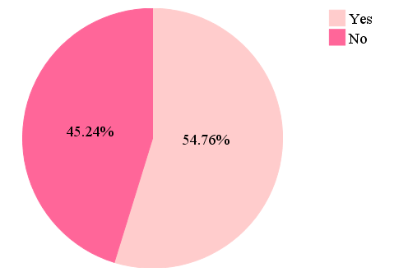
Figure 1 Supplement Consumption among Respondents

Table 2 Distribution of Supplements Compositions
Composition |  | Frequency (n) | Percentage (%)
Multivitamin | Vitamin A | 3 | 4.29
 | Vitamin B₁, B₆ and B₁₂ | 5 | 7.14
 | Vitamin C | 2 | 2.86
 | Vitamin D | 3 | 4.29
 | Vitamin E | 2 | 2.86
 | Vitamin K | 1 | 1.43
Mineral | Calcium | 2 | 2.86
 | Chlor | 1 | 1.43
 | Copper | 1 | 1.43
 | Iodine | 1 | 1.43
 | Iron | 1 | 1.43
 | Magnesium | 1 | 1.43
 | Manganese | 1 | 1.43
 | Phosphorus | 1 | 1.43
 | Potassium | 2 | 2.86
 | Sodium | 1 | 1.43
 | Zinc | 1 | 1.43
Herbs | Akar wangi | 1 | 1.43
 | Alfafa | 1 | 1.43
 | Aloevera | 1 | 1.43
 | Angelicae | 1 | 1.43
 | Apple vinegar | 1 | 1.43
 | Astragali | 1 | 1.43
 | Barley grass | 1 | 1.43
 | Brown rice powder | 1 | 1.43
 | Chlorella | 1 | 1.43
 | Chlorophyll | 1 | 1.43
 | Cinnamon | 3 | 4.29
 | Cistanchis | 1 | 1.43
 | Fish oil | 1 | 1.43
 | Dewa leaves | 1 | 1.43
 | Epimedii | 1 | 1.43
 | Eucommiae | 1 | 1.43
 | Gamat stichopus hermanii | 1 | 1.43
 | Garcina cambogia | 1 | 1.43
 | Garciniae pericarpium | 1 | 1.43
 | Ginseng | 2 | 2.86
 | Glucosamine sulphate | 1 | 1.43
 | Green tea | 1 | 1.43
 | Lignum | 1 | 1.43
 | Lycii | 1 | 1.43
 | Nigella sativa | 3 | 4.29
 | Psolarae | 1 | 1.43
 | Rosela flowers | 1 | 1.43
 | Spirulina plantesis | 2 | 2.86
 | White grass | 1 | 1.43
Other | Choline | 1 | 1.43
Without label composition |  | 5 | 7.14

The most commonly given reason for consumption was ‘try supplement on in order to gain better health status’ (52.9%). The second most common reason for utilization was ‘prescribed by doctor’ (38.3%) (Figure 2). Some doctors at Physical Medicine and Rehabilitation Clinic Dr. Hasan Sadikin General Hospital prescribed multivitamin or minerals supplements. The most frequent person or parties who suggested or recommend users to consumed supplements were doctors (38.24%) and relatives (26.47%) (Figure 3).

Figure 2 Reasons for using Supplement

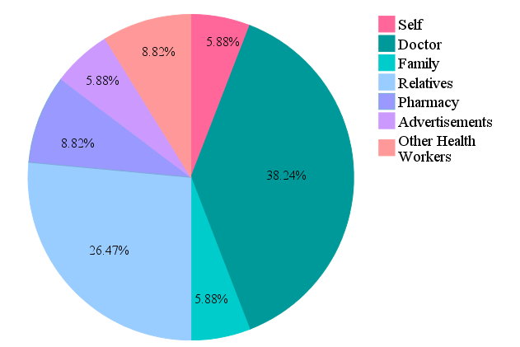
Figure 3 Supplement Consumption Recommendation

From 34 supplements used in this study, 44.12% supplements drove respondents to greater health status, subjectively. Respondents felt that they had better health condition after consuming supplements such as more energized, mobilization and ambulation improvement, increase appetite, and decrease blood pressure. In contrast, respondents who consumed 55.88% other supplements felt there is no difference between consuming or not consuming supplements. They did not feel any effect that emerges after using supplements (Figure 4).
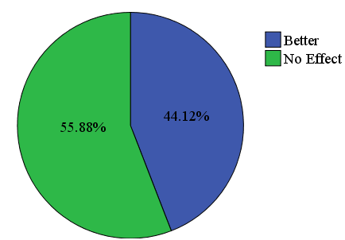
Figure 4 Perceptions of Supplement Consumption Effects

Discussion
Demographic information between respondents in this study showed some similarities with Indonesian and South East Asia population, possibility could be relevant to the same race or ethnicity, lifestyle, and behavior. The equal proportion between male (50%) and female (50%) respondents might represent the sex ratio of stroke patients in Indonesia (male 54.7% : female 45.3%).¹⁴ The respondent’s mean age was 58.1 years old, nearly similar with mean age of South East Asia region stroke patients (59.9 years old). The distribution of stroke diagnosis in the study was dominated by ischemic (infarct) stroke (88.1%), just the same as in South East Asia region although with different proportion (77.7%).¹⁵ Higher mortality rate of hemorrhagic stroke might be reason that stand behind this phenomenon.¹⁶
Most respondents in this study were poorly educated; one third of them stopped their formal education after they graduated elementary school. Moreover, there were still respondents who did not graduated elementary school (4.8%). The preponderance of respondents (64.3%) had low or minimum income (unemployed, housewife, and retirement). This scene could be corresponded with Indonesia’s 107th ranking position on Human Development Index United Nations Development Programme (UNDP) 2007 that indicates low health, educational, and income level.¹⁷ Educational and occupational status might influence respondents’ preferences and purchasing power on supplements.
Our results showed that more than half of poststroke patients (54.8%) consumed one or more supplements after their stroke event, with mean 1.48 supplement use. There was no data explained about supplement use among poststroke patients, either in Indonesia nor global. While our finding is nearly compatible with some other study results, such as data collected by the Food and Drug Administration (FDA) that indicated 55% of the adults surveyed used some type of dietary supplements; and National Health and Nutrition Examination Survey (NHANES) data collected from 2003 to 2006 that covered all types of dietary supplements indicate 53% of American adults took at least one dietary supplement, most commonly multivitamin/mineral supplement.¹³
The most commonly used supplements by poststroke patients in this study were categorized into herbs supplements (55.8%), followed by multivitamin supplements (29.41%). There was no previous data measure herbs supplements utilization among stroke patients. But, according to the 2007 National Health Interview Survey, which included questions on Americans’ use of natural products (not including vitamins and minerals), 17.7 percent of American adults had used these types of products in the past 12 months.^{10, 18}
The most common herbs composed in the herbs supplements of this study are Nigella sativa, cinnamon, ginseng, and spirulina. Study in Pakistan¹⁹ found that Nigella sativa produces antiatherogenic effect by decreasing lipoprotein cholesterol level and increases high density lipoprotein level. Medicinal Plants of Asia and The Pacific mentioned that cinnamon had anti spasmodic and anti diabetic effects. Foster et al. concluded in their book that ginseng prevents platelet aggregation, improves physical performance and quality of life.²⁰ Spirulina known to have twice much vitamin B₁₂ as liver, in addition to have many other B vitamins, vitamin A and E, and minerals.²⁰ These explanations might be the reason of high herb supplement use in stroke patients.
Even though herbs supplement was the most frequent supplement used, from all 34 supplements, the most commonly used ingredients were vitamin B₁, B₆ and B₁₂. There were several large and small-scale randomized clinical trials assess the effect of vitamin B supplementation on cardiovascular mortality and morbidity, including stroke. VISP trial on 3680 cerebral infarction patients from 1997 to 2001 which given randomized daily dose of 2.5 mg folic acid, 0.4 mg vitamin B₁₂ and 25 mg vitamin B₆; or 20μg, 6μg, and 200μg respectively for 2 years. The trial showed that vitamin B had no effect on cardiovascular risk. Women’s Antioxidant and Folic Acid Cardiovascular Study (WAFACS) follow up study assessed the effect of B-vitamins (2.5 mg folic acid, 50 mg vitamin B6 and 1 mg vitamin B12) to 5442 women with cardiovascular disease history for median duration of 7.3 years concluded that there was no difference between placebo and active vitamin B treatment groups in terms of myocardial infarction and stroke risks despite an 18.5% decrease in homocysteine level.¹² Saposnik et al. ¹¹ outcome analysis on Heart Outcomes Prevention Evaluation (HOPE) 2 trial participants concluded that lowering of homocysteine with folic acid and vitamin B₆ and B₁₂ did reduce the risk of overall stroke, but not stroke severity and disability.
Most of supplements in this study were purchased over of the counter (OTC), not based on doctor’s prescription or suggestion. Either relative including friends and neighbors, family, pharmacy, advertisement, or even health care workers like nurse and acupuncturist were the agents who informed, recommended, and persuaded respondents to use selected supplements. Only 38% supplements that suggested by doctor. Maybe this tangibility correlates with patients’ health seeking behavior. Health seeking behavior is any action undertaken by individuals who perceive themselves to have a health problem or to be ill for the purpose of finding an appropriate remedy. Health seeking behavior correlates with age, gender, education, socioeconomic status, geographic and culture, health belief, experience, and satisfaction to quality service received.
Most respondents felt no improvement after using supplements, subjectively. Moreover, from respondents who felt gain better health status, there was only one patient felt improvement in ambulation; which ambulation improvement is one of stroke recovery outcomes. However, respondent’s perception did not represent their real health status. Because this study only conduct subjective feelings, so what respondents felt might be just placebo effects, or maybe there was an effect in patients body but the effect could not be feel.
In conclusion, more than a half of poststroke patients at Physical Medicine and Rehabilitation Clinic in Dr. Hasan General Sadikin Hospital were supplement users, with mean of consumption 1.48 supplements. Majority of supplements used were herbs supplements, followed by multivitamin supplements, mineral supplements, multivitamin and mineral supplements, and other. The most frequent ingredients used in this study were vitamin B₁, B₆, and B₁₂. Most of supplements users in poststroke patients get the supplements over the counter (OTC). Supplements users get all of herbs supplements OTC, while they get all of the multivitamin supplements from doctor’s prescription and pharmacy. One fourth of the herbs supplements in this study were circulating in the market without brand label and information. The most commonly given reason for supplement consumption was ‘try supplement on in order to gain better health status. But, more than a half of the users did not felt any effect of improvement.
Limitation of this study were the small number of respondents caused by inadequate time in collecting data; and the outcome parameter after consumed supplements that only measure subjective effects felt by respondents. What respondents felt might be just placebo effects; effects from another medication and rehabilitation treatment, not from supplements; or maybe there was a supplement effect in respondents’ body, but the effect could not be feel.

Reference

- Hardie K, Hankey GJ, Jamrozik K, Broadhurst RJ, Anderson C. Ten-year risk of first recurrent stroke and disability after first-ever stroke in the Perth Community Stroke Study. Stroke. 2004;35(3):731−5.

2. WHO. Global burden of stroke. World Health Organization, 2004.

3. Sturm JW, Dewey HM, Donnan GA, Macdonell RAL, McNeil JJ, Thrift AG. Handicap after stroke: how does it relate to disability, perception of recovery, and stroke subtype? : The North East Melbourne Stroke Incidence Study (NEMESIS). Stroke. 2002;33(3):762−8.

4. Carmichael ST. Themes and strategies for studying the biology of stroke recovery in the poststroke epoch. Stroke. 2008;39(4):1380−8.

5. Benowitz LI, Carmichael ST. Promoting axonal rewiring to improve outcome after stroke. Neurobiol Dis. 2010;37(2):2559−2566.

6. Snell RS. Clinical neuroanatomy. 7th ed. Baltimore: Lippincott Williams & Wilkins; 2010. p 542.

7. Fitzgerald MJT, Gruener G, Mtui E. Clinical neuroanatomy and neuroscience. 5th ed. Philadelphia: Elsevier Saunders; 2007.

8. Frontera WR, Silver JK, Thomas D. Rizzo J. Essentials of physical medicine and rehabilitation: musculoskeletal disorder, pain, and rehabilitation. 2nd ed. Canada: Saunders Elsevier; 2008.

9. Duncan PW, Zorowitz R, Bates B, Choi JY, Glasberg JJ, Graham GD, et al. Management of adult stroke rehabilitation care: a clinical practice guideline. Stroke. 2005;36(9):e100−43.

10. Onel, Suzan. Dietary supplements: a definition that is black, white, and gray. Am. J.L. & Med. 2005;31:341−8.

11. Saposnik G, Ray JG, Sheridan P, McQueen M, Lonn E. Homocysteine-lowering therapy and stroke risk, severity, and disability: additional findings from the HOPE 2 trial. Stroke. 2009;40(4):1365−72.

12. Ntaios G, Savopoulos C, Grekas D, Hatzitolios A. The controversial role of B-vitamins in cardiovascular risk: an update. Arch Cardiovasc Dis. 2009;102(12):847−54.

13. Gahche J, Bailey R, Burt V, Hughes J, Yetley E, Dwyer J, et al. Dietary supplement use among US adults has increased since NHANES III (1988−1994). NCHS Data Brief. 2011;6(1):1−8.
14. BPPK. Riset Kesehatan Dasar (Riskesdas) 2007. Jakarta: Kemenkes RI. 2007.

15. Venketasubramanian N. The epidemiology of stroke in ASEAN countries - a review. Neurol J Southeast Asia. 1998;3:9−14.

16. Truelsen T, Begg S, Mathers C. The global burden of cerebrovascular disease. Global Burden of Disease. 2006.

17. Keputusan Menteri Kesehatan Indonesia Nomor 263/Menkes/SK/II/2010 Tentang Pedoman Rehabilitasi Kognitif. Jakarta: Kemenkes RI. 2010.

18. Ayranci U, Son N, Son O. Prevalence of nonvitamin, nonmineral supplement usage among students in a Turkish university. BMC Public Health. 2005; 5:47.

19. Bhatti IU, Rehman FU, Khan MA, Marwat SK. Effect of Propheitic Medicine Kalonji (Nigella sativa L.) On lipid profile of human beings: an in vivo approach. World Appl Sci J. 2009;6(8):1053−7.

20. Foster S, Varoo E, Tyler P. Tyler's honest herbal a sensible guide to the use of herbs and related remedies. 4th ed. New York: The Hawsworth Press, Inc. 1999.

Appendix 1. Ethical Clearance Approval
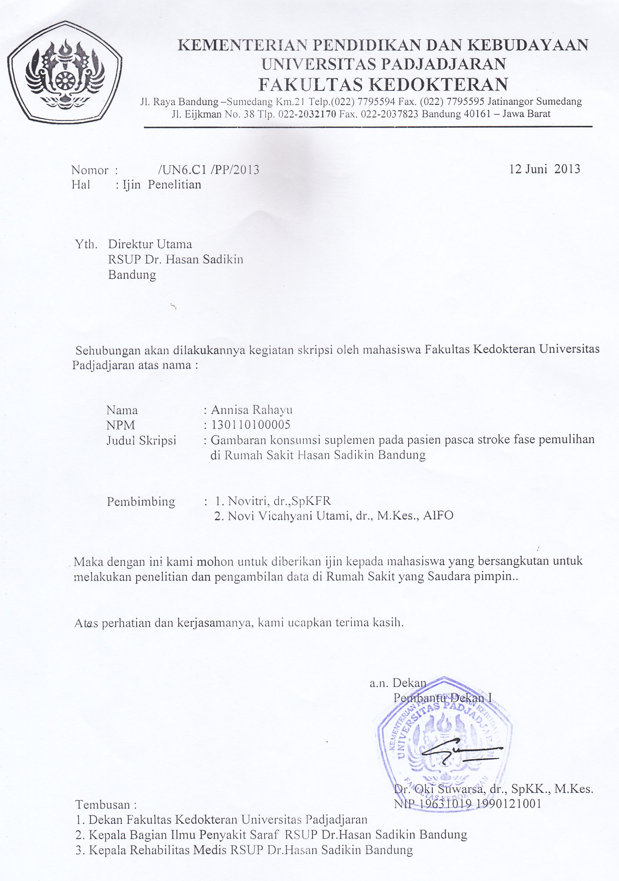
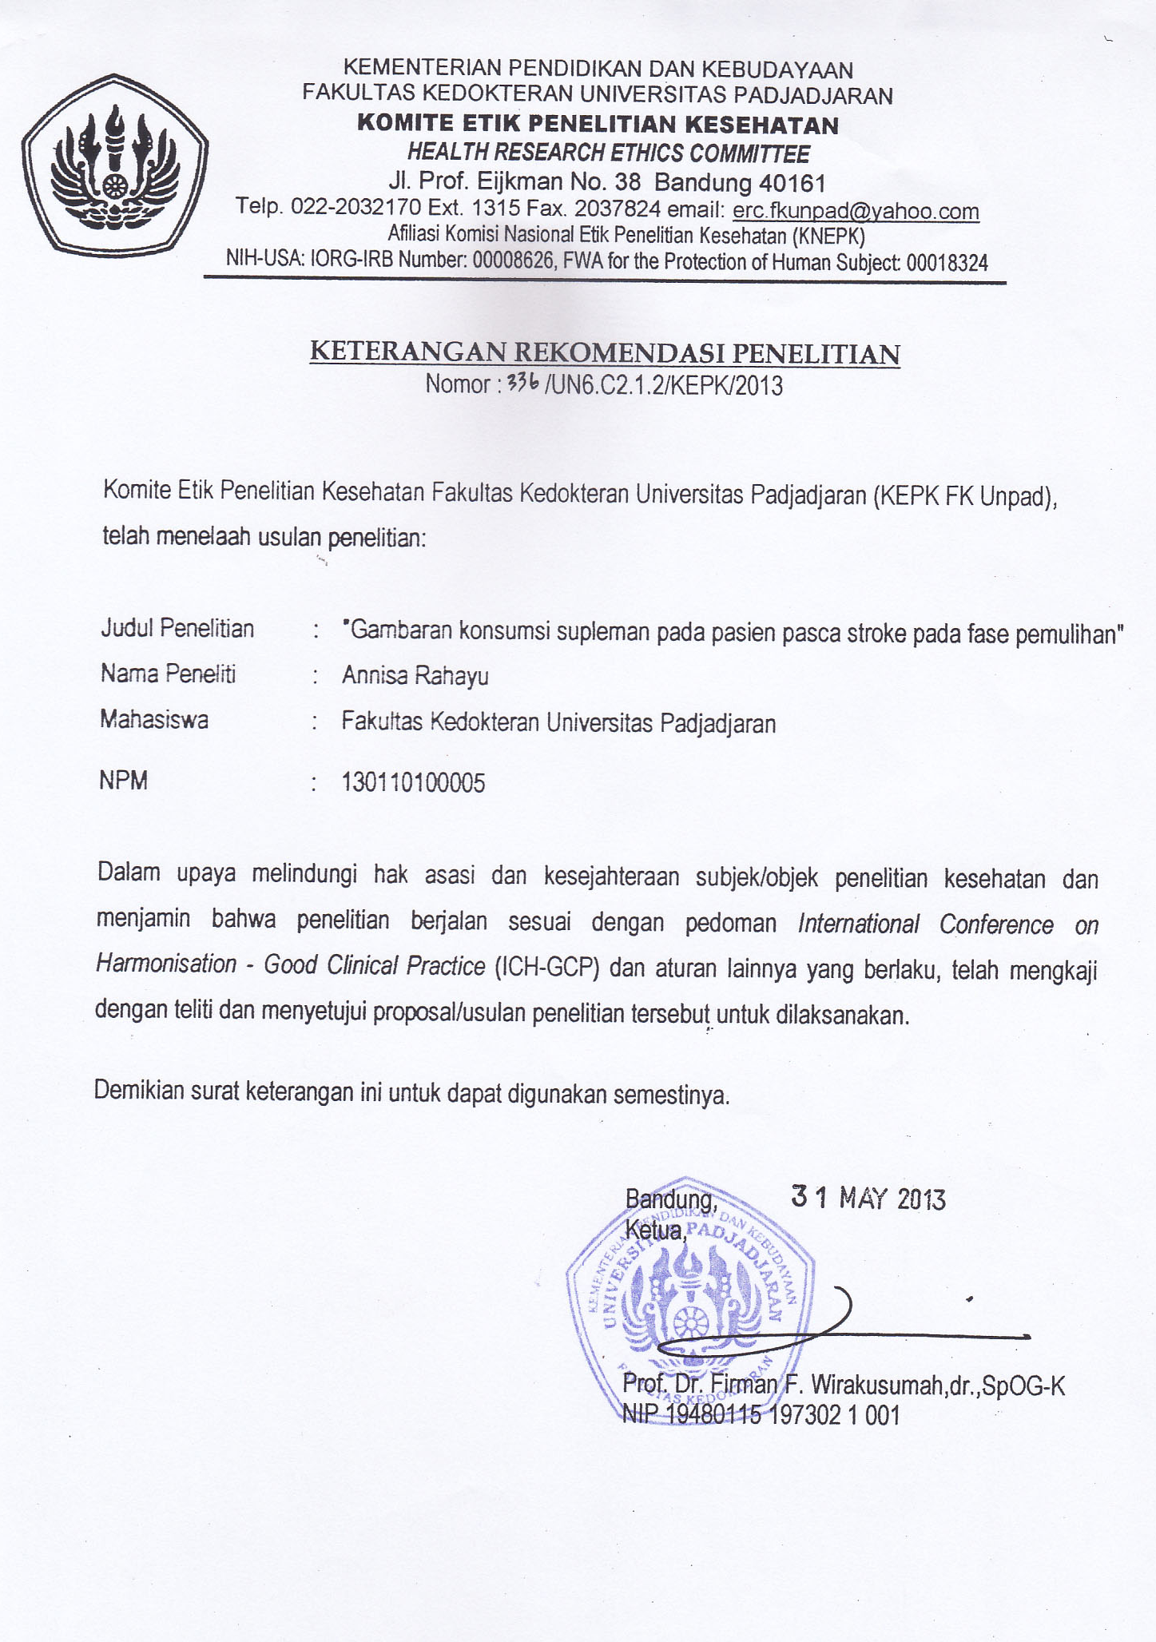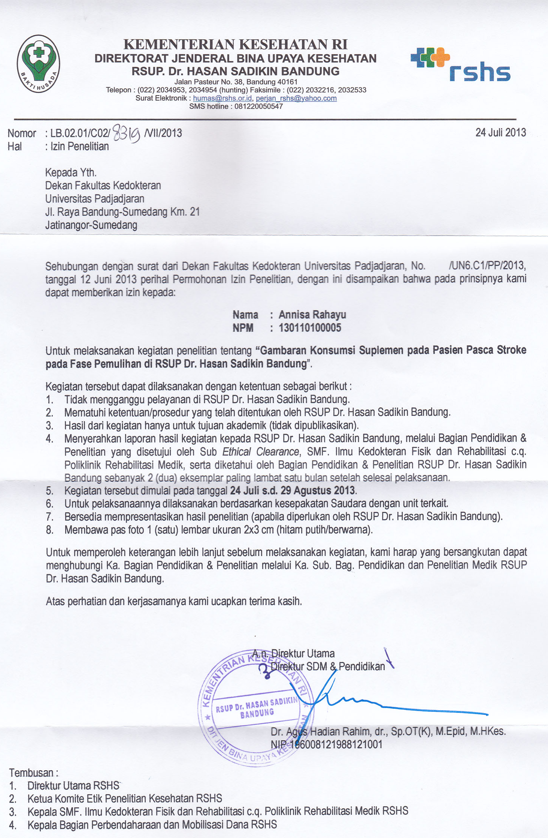
Appendix 2. Questionnaire for Structured Interview
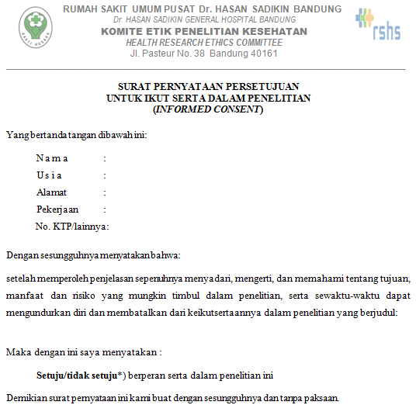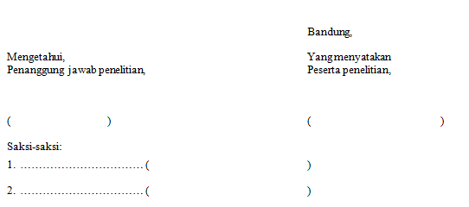
No. Sampel :
Tanggal wawancara :

LEMBAR WAWANCARA
GAMBARAN KONSUMSI SUPLEMEN PADA PASIEN PASCASTROKE FASE PEMULIHAN DI RUMAH SAKIT HASAN SADIKIN BANDUNG

- Nama :
- Usia : tahun
- Jenis kelamin :
- Alamat :
- Pekerjaan :
- Pendidikan terakhir : a. Tidak tamat SD
b. SD
c. SMP
d. SMA
e. Perguruan tinggi
- Jenis stroke :
- Kejadian stroke ke- :
- Tanggal kejadian stroke :

Format Pertanyaan
- Pertanyaan utama :
Setelah kejadian stroke, apakah Anda pernah mengonsumsi suplemen?
- Ya
- Tidak
Jika ya, maka lanjut ke pertanyaan khusus.

- Pertanyaan khusus :
- Berapa jumlah (macam) suplemen yang Anda minum?
- Apakah nama produk (merek) suplemen yang Anda konsumsi?
- Apakah jenis suplemen yang Anda konsumsi? (per suplemen, jawaban bisa lebih dari satu)
- Multivitamin
- Mineral
- Bahan alam
- Lainnya, (sebutkan)
- Apa bentuk sediaan suplemen yang Anda konsumsi? (per suplemen)
- Pil
- Tablet
- Kapsul
- Serbuk
- Cairan
- Lainnya
- Apa saja kandungan/komposisi yang terdapat pada suplemen yang Anda konsumsi? (per suplemen)
- Sudah berapa lama Anda mengonsumsi suplemen tersebut? (per suplemen)
- Kurang dari enam bulan
- Lebih dari enam bulan
- Siapa yang pertama kali menyarankan Anda untuk mengonsumsi suplemen tersebut?
- Tidak ada yang menyarankan, dari diri sendiri
- Dokter
- Keluarga
- Kerabat
- Farmasi
- Media periklanan
- Lainnya
- Apa alasan Anda mengonsumsi suplemen tersebut?
- Setelah mengonsumi suplemen tersebut, adakah efek yang Anda rasakan?

Format Isian Wawancara (diisi oleh pewawancara)
Mengonsumsi suplemen : Ya/Tidak
Jumlah suplemen :

 | Suplemen 1 | Suplemen 2 | Suplemen 3 | Suplemen 4
Nama (Merek)
Jenis
Sediaan
Kandungan
Lama konsumsi
Asal suplemen
Alasan
Efek

Appendix 3. Raw Data
No. Sam-ple | Age | Sex | Occupation | Education | Stroke events | Diagnosis | Stroke Phase | Suppl-ement Use | Total Use | No. of Brand Name | Class | Composition | Recomm-endation | Reason | Subjective Effects
1 | 56 | F | Unemployee | Ungraduated elementary school | First | Ischemic | Chronic | No
2 | 51 | F | Businessman | Senior high school | Reccurent | Ischemic | Chronic | No
3 | 65 | F | Housewife | Elementary school | First | Ischemic | Chronic | No
4 | 60 | M | Retirement | College | First | Ischemic | Subacute | Yes | 1 | 1 | Herbs | Green tea leaves | Relatives | Try on | No effect
5 | 47 | M | Goverment worker | College | Reccurent | Hemorragic | Chronic | Yes | 1 | 2 | Herbs | White grass, barley grass, spirulina, chlorella, alfafa, chlorophyll, aloevera, garcina cambogia, brown rice powder, apple vinegar | Relatives | Try on | Better
6 | 55 | M | Businessman | Senior high school | First | Ischemic | Chronic | No
7 | 70 | M | Labor | Elementary school | First | Ischemic | Subacute | Yes | 2 | 3 | Multi-vitamin | Vitamin B1, B6, B12 | Doctor | Doctor's prescription | Better, walking improve
 |  |  |  |  |  |  |  |  |  | 4 | Herbs | Akar wangi, Ginseng, Sirih, cinnamon | Relatives | Try on | Better
8 | 56 | M | Retirement | College | Reccurent | Ischemic | Subacute | Yes | 1 | 5 | Herbs | Fish oil | Relatives | Try on | No effect
9 | 58 | F | Housewife | Ungraduated elementary school | First | Ischemic | Subacute | No
10 | 48 | F | Businessman | Elementary school | First | Ischemic | Chronic | Yes | 1 | 3 | Multi-vitamin | Vitamin B1, B6, B12 | Doctor | Doctor's prescription | No effect
11 | 65 | F | Housewife | Elementary school | First | Ischemic | Subacute | No
12 | 61 | M | Unemployee | Senior high school | First | Ischemic | Subacute | No
13 | 66 | F | Housewife | Elementary school | Reccurent | Ischemic | Chronic | Yes | 1 | 6 | Herbs | Dewa leaves | Relatives | Try on | No effect
14 | 50 | F | Housewife | Junior high school | Reccurent | Hemorragic | Subacute | Yes | 3 | No brand name | Herbs | Without label of ingredients | Self | Try on | No effect
 |  |  |  |  |  |  |  |  |  | 7 | Herbs | Rosela flowers | Relatives | Try on | Better, decrease BP
 |  |  |  |  |  |  |  |  |  | No brand name | Herbs | Sirih merah, mahkota dewa | Family | Try on | Better, decrease BP
15 | 68 | M | Retirement | College | Reccurent | Ischemic | Subacute | No
16 | 62 | F | Housewife | Elementary school | First | Ischemic | Subacute | No
17 | 70 | F | Housewife | Elementary school | Reccurent | Ischemic | Subacute | Yes | 1 | No brand name | Herbs | Without label of ingredients | Acupu-ncturist | Acupu-ncturist's prescription | Better
18 | 56 | F | Housewife | Elementary school | First | Ischemic | Subacute | Yes | 1 | 3 | Multi-vitamin | Vitamin B1, B6, B12 | Doctor | Doctror's prescription | No effect
19 | 51 | F | Goverment worker | College | First | Ischemic | Subacute | No
20 | 62 | M | Retirement | Senior high school | First | Ischemic | Chronic | Yes | 1 | No brand name | Herbs | Without label of ingredients | Relatives | Try on | Better
21 | 63 | M | Retirement | Senior high school | Reccurent | Ischemic | Chronic | Yes | 2 | 8 | Herbs | 34% extract Gamat Stichopus hermanii (extract tripang) | Adver-tisement (poster) | Try on | Better
 |  |  |  |  |  |  |  |  |  | 9 | Herbs | Spirulina plantesis |  |  | Better
22 | 73 | M | Retirement | College | Reccurent | Ischemic | Subacute | Yes | 2 | 10 | Multi-vitamin | Vitamin B1, B6, B12 | Doctor | Doctor's prescription | No effect
 |  |  |  |  |  |  |  |  |  | 11 | Mineral | Calcium carbonate | Doctor | Doctor's prescription | No effect
23 | 80 | M | Goverment worker | College | First | Ischemic | Chronic | Yes | 1 | 12 | Multi-vitamin & Mineral | Protein, Carbohydrate, Fat, Fiber, Vitamin (A, B1, B12, C, D, E), Minerals (Ca, Phospor, Iodine, Mg, Copper, Zn, Cl, K, Na, Mn, Iron) | Doctor | Doctor's prescription | No effect
24 | 45 | M | Businessman | Senior high school | First | Hemorragic | Subacute | Yes | 2 | 3 | Multi-vitamin | Vitamin B1, B6, B12 | Doctor | Doctor's prescription | No effect
 |  |  |  |  |  |  |  |  |  | No brand name | Herbs | Without label of ingredients | Relatives | Try on | No effect
25 | 49 | M | Government worker | College | First | Ischemic | Chronic | Yes | 2 | 3 | Multi-vitamin | Vitamin B1, B6, B12 | Doctor | Doctor's prescription | Better
 |  |  |  |  |  |  |  |  |  | 13 | Herbs | Ginseng, cordyceps, astragali, angelicae, rehmanniae, lycii, lignum, psolarae, epimedii, eucommiae , cinnamomum, cistanchis | Pharmacy | Try on | Better
26 | 48 | M | Labor | Elementary school | Reccurent | Ischemic | Subacute | No
27 | 52 | F | Goverment worker | College | First | Hemorragic | Subacute | Yes | 1 | 14 | Herbs | Garciniae pericarpium | Nurse | Try on | No effect
28 | 65 | F | Unemployee | Elementary school | First | Ischemic | Chronic | Yes | 1 | 15 | Multi-vitamin | Vitamin A, D, E, K, C, B1, B6, B12 complex | Pharmacy | Try on | Better, appetite also increase
29 | 58 | M | Businessman | Elementary school | Reccurent | Ischemic | Subacute | No
30 | 72 | M | Unemployee | Senior high school | First | Ischemic | Chronic | Yes | 2 | 3 | Multi-vitamin | Vitamin B1, B6, B12 | Doctor | Doctor's prescription | Better
 |  |  |  |  |  |  |  |  |  | 16 | Herbs | Nigella sativa | Family | Try on | Better
31 | 42 | F | Housewife | Elementary school | Reccurent | Ischemic | Subacute | No
32 | 54 | M | Unemployee | Junior high school | Reccurent | Ischemic | Subacute | No
33 | 65 | M | Businessman | Senior high school | Reccurent | Ischemic | Subacute | Yes | 1 | 16 | Herbs | Nigella sativa | Relatives | Try on | No effect
34 | 58 | F | Unemployee | Elementary school | Reccurent | Ischemic | Subacute | No
35 | 58 | F | Unemployee | Junior high school | Reccurent | Ischemic | Subacute | Yes | 1 | 17 | Multi-vitamin | Vitamin A, D, B1, B6, B12 | Doctor | Doctor's suggestion | No effect
36 | 42 | F | Housewife | Junior high school | Reccurent | Ischemic | Subacute | No
37 | 59 | F | Retirement | Senior high school | First | Ischemic | Chronic | Yes | 2 | 18 | Herbs | Glucosamine sulphate | Pharmacy | Try on | Better
 |  |  |  |  |  |  |  |  |  | 10 | Multi-vitamin | Vitamin B1, B6, B12 | Doctor | Doctor's prescription | No effect
38 | 73 | M | Retirement | Senior high school | First | Hemorragic | Subacute | No
39 | 50 | F | Housewife |  | Reccurent | Ischemic | Subacute | Yes | 2 | 19 | Other | Choline | Doctor | Doctor's prescription | No effect
 |  |  |  |  |  |  |  |  |  | 20 | Mineral | Pottasium klorida | Doctor | Doctor's prescription | No effect
40 | 58 | M | Retirement | College | First | Ischemic | Chronic | Yes | 2 | 16 | Herbs | Nigella sativa | Self | Try on | No effect
 |  |  |  |  |  |  |  |  |  | 12 | Multi-vitamin & Mineral | Protein, Carbohydrate, Fat, Fiber, Vitamin (A, B1, B12, C, D, E), Minerals (Ca, Phospor, Iodine, Mg, Copper, Zn, Cl, K, Na, Mn, Iron) | Nurse | Try on | No effect
41 | 52 | F | Businessman | Elementary school | Reccurent | Ischemic | Chronic | No
42 | 52 | M | Businessman | Senior high school | Reccurent | Ischemic | Subacute | No

Appendix 4. Statistical Analysis
Frequencies
Notes

Output Created |  | 21-NOV-2013 08:14:51
Comments
Input | Data | D:\Minor Thesis\SPSS\spss1.sav
Input | Active Dataset | DataSet1
Input | Filter | <none>
Input | Weight | <none>
Input | Split File | <none>
Input | N of Rows in Working Data File | 42
Missing Value Handling | Definition of Missing | User-defined missing values are treated as missing.
Missing Value Handling | Cases Used | Statistics are based on all cases with valid data.
Syntax |  | FREQUENCIES  VARIABLES=Age  /NTILES= 4  /STATISTICS=MEAN MEDIAN MODE  /ORDER= ANALYSIS .
Resources | Elapsed Time | 0:00:00.00
Resources | Processor Time | 0:00:00.00

Statistics
Age
N | Valid | 42
N | Missing | 0
Mean |  | 58.21
Median |  | 58.00
Mode |  | 58
Percentiles | 25 | 51.00
Percentiles | 50 | 58.00
Percentiles | 75 | 65.00

Age
 |  | Frequency | Percent | Valid Percent | Cumulative Percent
Valid | 42 | 2 | 4.8 | 4.8 | 4.8
Valid | 45 | 1 | 2.4 | 2.4 | 7.1
Valid | 47 | 1 | 2.4 | 2.4 | 9.5
Valid | 48 | 2 | 4.8 | 4.8 | 14.3
Valid | 49 | 1 | 2.4 | 2.4 | 16.7
Valid | 50 | 2 | 4.8 | 4.8 | 21.4
Valid | 51 | 2 | 4.8 | 4.8 | 26.2
Valid | 52 | 3 | 7.1 | 7.1 | 33.3
Valid | 54 | 1 | 2.4 | 2.4 | 35.7
Valid | 55 | 1 | 2.4 | 2.4 | 38.1
Valid | 56 | 3 | 7.1 | 7.1 | 45.2
Valid | 58 | 5 | 11.9 | 11.9 | 57.1
Valid | 59 | 1 | 2.4 | 2.4 | 59.5
Valid | 60 | 1 | 2.4 | 2.4 | 61.9
Valid | 61 | 1 | 2.4 | 2.4 | 64.3
Valid | 62 | 2 | 4.8 | 4.8 | 69.0
Valid | 63 | 1 | 2.4 | 2.4 | 71.4
Valid | 65 | 4 | 9.5 | 9.5 | 81.0
Valid | 66 | 1 | 2.4 | 2.4 | 83.3
Valid | 68 | 1 | 2.4 | 2.4 | 85.7
Valid | 70 | 2 | 4.8 | 4.8 | 90.5
Valid | 72 | 1 | 2.4 | 2.4 | 92.9
Valid | 73 | 2 | 4.8 | 4.8 | 97.6
Valid | 80 | 1 | 2.4 | 2.4 | 100.0
Valid | Total | 42 | 100.0 | 100.0

Frequencies

Notes

Output Created |  | 21-NOV-2013 08:15:24
Comments
Input | Data | D:\Minor Thesis\SPSS\spss1.sav
Input | Active Dataset | DataSet1
Input | Filter | <none>
Input | Weight | <none>
Input | Split File | <none>
Input | N of Rows in Working Data File | 42
Missing Value Handling | Definition of Missing | User-defined missing values are treated as missing.
Missing Value Handling | Cases Used | Statistics are based on all cases with valid data.
Syntax |  | FREQUENCIES  VARIABLES=agecategoo Sex Occupation Education Diagnosis Event  Classification Supplement_Consumption  /NTILES= 4  /STATISTICS=MEAN MEDIAN MODE  /ORDER= ANALYSIS .
Resources | Elapsed Time | 0:00:00.02
Resources | Processor Time | 0:00:00.03

Statistics
 |  | Age Category | Sex | Occupation | Education | Diagnosis | Event | Stroke Classification | Supplement Consumption
N | Valid | 42 | 42 | 42 | 42 | 42 | 42 | 42 | 42
 | Missing | 0 | 0 | 0 | 0 | 0 | 0 | 0 | 0

Age Category
 |  | Frequency | Percent | Valid Percent | Cumulative Percent
Valid | 40-44 | 2 | 4.8 | 4.8 | 4.8
Valid | 45-49 | 5 | 11.9 | 11.9 | 16.7
Valid | 50-54 | 8 | 19.0 | 19.0 | 35.7
Valid | 55-59 | 10 | 23.8 | 23.8 | 59.5
Valid | 60-64 | 5 | 11.9 | 11.9 | 71.4
Valid | 65-69 | 6 | 14.3 | 14.3 | 85.7
Valid | 70-74 | 5 | 11.9 | 11.9 | 97.6
Valid | 80-84 | 1 | 2.4 | 2.4 | 100.0
Valid | Total | 42 | 100.0 | 100.0

Sex
 |  | Frequency | Percent | Valid Percent | Cumulative Percent
Valid | Male | 21 | 50.0 | 50.0 | 50.0
Valid | Female | 21 | 50.0 | 50.0 | 100.0
Valid | Total | 42 | 100.0 | 100.0

Occupation
 |  | Frequency | Percent | Valid Percent | Cumulative Percent
Valid | Unemployee | 7 | 16.7 | 16.7 | 16.7
Valid | Housewife | 11 | 26.2 | 26.2 | 42.9
Valid | Retirement | 9 | 21.4 | 21.4 | 64.3
Valid | Labor | 2 | 4.8 | 4.8 | 69.0
Valid | Entrepreneur | 8 | 19.0 | 19.0 | 88.1
Valid | Goverment Worker | 5 | 11.9 | 11.9 | 100.0
Valid | Total | 42 | 100.0 | 100.0

Education
 |  | Frequency | Percent | Valid Percent | Cumulative Percent
Valid | Ungraduated Elementary School | 2 | 4.8 | 4.8 | 4.8
Valid | Elementary School | 14 | 33.3 | 33.3 | 38.1
Valid | Junior High School | 4 | 9.5 | 9.5 | 47.6
Valid | Senior High School | 12 | 28.6 | 28.6 | 76.2
Valid | College | 10 | 23.8 | 23.8 | 100.0
Valid | Total | 42 | 100.0 | 100.0

Diagnosis
 |  | Frequency | Percent | Valid Percent | Cumulative Percent
Valid | Infark (ischemia) | 37 | 88.1 | 88.1 | 88.1
Valid | Hemorragic | 5 | 11.9 | 11.9 | 100.0
Valid | Total | 42 | 100.0 | 100.0

Event
 |  | Frequency | Percent | Valid Percent | Cumulative Percent
Valid | First | 22 | 52.4 | 52.4 | 52.4
Valid | Reccurent | 20 | 47.6 | 47.6 | 100.0
Valid | Total | 42 | 100.0 | 100.0

Stroke Classification
 |  | Frequency | Percent | Valid Percent | Cumulative Percent
Valid | Subacute | 26 | 61.9 | 61.9 | 61.9
Valid | Chronic | 16 | 38.1 | 38.1 | 100.0
Valid | Total | 42 | 100.0 | 100.0

Supplement Consumption
 |  | Frequency | Percent | Valid Percent | Cumulative Percent
Valid | Yes | 23 | 54.8 | 54.8 | 54.8
Valid | No | 19 | 45.2 | 45.2 | 100.0
Valid | Total | 42 | 100.0 | 100.0

Statistics
Total Supplement
N | Valid | 42
N | Missing | 0
Mean |  | .81
Median |  | 1.00
Mode |  | 0
Sum |  | 34
Percentiles | 25 | .00
Percentiles | 50 | 1.00
Percentiles | 75 | 1.25

Total Supplement
 |  | Frequency | Percent | Valid Percent | Cumulative Percent
Valid | 0 | 19 | 45.2 | 45.2 | 45.2
Valid | 1 | 13 | 31.0 | 31.0 | 76.2
Valid | 2 | 9 | 21.4 | 21.4 | 97.6
Valid | 3 | 1 | 2.4 | 2.4 | 100.0
Valid | Total | 42 | 100.0 | 100.0

Frequencies

Notes

Output Created |  | 21-NOV-2013 08:16:31
Comments
Input | Data | D:\Minor Thesis\SPSS\merek obat.sav
Input | Active Dataset | DataSet2
Input | Filter | <none>
Input | Weight | <none>
Input | Split File | <none>
Input | N of Rows in Working Data File | 34
Missing Value Handling | Definition of Missing | User-defined missing values are treated as missing.
Missing Value Handling | Cases Used | Statistics are based on all cases with valid data.
Syntax |  | FREQUENCIES  VARIABLES=Merek Jenis Asal Alasan Effect  /ORDER= ANALYSIS .
Resources | Elapsed Time | 0:00:00.00
Resources | Processor Time | 0:00:00.00

Statistics

 |  | Brand Name | Category | Recommendation | Reason | Subjective Effect
N | Valid | 34 | 34 | 34 | 34 | 34
N | Missing | 0 | 0 | 0 | 0 | 0

Statistics

 |  | Brand Name | Category | Recommendation | Reason | Subjective Effect
N | Valid | 34 | 34 | 34 | 34 | 34
N | Missing | 0 | 0 | 0 | 0 | 0

Brand Name
 |  | Frequency | Percent | Valid Percent | Cumulative Percent
Valid | 0 | 5 | 14.7 | 14.7 | 14.7
Valid | 1 | 1 | 2.9 | 2.9 | 17.6
Valid | 10 | 2 | 5.9 | 5.9 | 23.5
Valid | 11 | 1 | 2.9 | 2.9 | 26.5
Valid | 12 | 2 | 5.9 | 5.9 | 32.4
Valid | 13 | 1 | 2.9 | 2.9 | 35.3
Valid | 14 | 1 | 2.9 | 2.9 | 38.2
Valid | 15 | 1 | 2.9 | 2.9 | 41.2
Valid | 16 | 3 | 8.8 | 8.8 | 50.0
Valid | 17 | 1 | 2.9 | 2.9 | 52.9
Valid | 18 | 1 | 2.9 | 2.9 | 55.9
Valid | 19 | 1 | 2.9 | 2.9 | 58.8
Valid | 2 | 1 | 2.9 | 2.9 | 61.8
Valid | 20 | 1 | 2.9 | 2.9 | 64.7
Valid | 3 | 6 | 17.6 | 17.6 | 82.4
Valid | 4 | 1 | 2.9 | 2.9 | 85.3
Valid | 5 | 1 | 2.9 | 2.9 | 88.2
Valid | 6 | 1 | 2.9 | 2.9 | 91.2
Valid | 7 | 1 | 2.9 | 2.9 | 94.1
Valid | 8 | 1 | 2.9 | 2.9 | 97.1
Valid | 9 | 1 | 2.9 | 2.9 | 100.0
Valid | Total | 34 | 100.0 | 100.0

Category
 |  | Frequency | Percent | Valid Percent | Cumulative Percent
Valid | Herbs | 19 | 55.9 | 55.9 | 55.9
Valid | Multivitamin | 10 | 29.4 | 29.4 | 85.3
Valid | Mineral | 2 | 5.9 | 5.9 | 91.2
Valid | Multivitamin and Mineral | 2 | 5.9 | 5.9 | 97.1
Valid | Neurotransmitter | 1 | 2.9 | 2.9 | 100.0
Valid | Total | 34 | 100.0 | 100.0

Recommendation

 |  | Frequency | Percent | Valid Percent | Cumulative Percent
Valid | Self | 2 | 5.9 | 5.9 | 5.9
Valid | Doctor | 13 | 38.2 | 38.2 | 44.1
Valid | Family | 2 | 5.9 | 5.9 | 50.0
Valid | Relatives | 9 | 26.5 | 26.5 | 76.5
Valid | Pharmacy | 3 | 8.8 | 8.8 | 85.3
Valid | Advertisements | 2 | 5.9 | 5.9 | 91.2
Valid | Other Health Workers | 3 | 8.8 | 8.8 | 100.0
Valid | Total | 34 | 100.0 | 100.0

Reason
 |  | Frequency | Percent | Valid Percent | Cumulative Percent
Valid | Give a try | 18 | 52.9 | 52.9 | 52.9
Valid | Prescribed by doctor | 13 | 38.2 | 38.2 | 91.2
Valid | Prescribed by acupucturist | 1 | 2.9 | 2.9 | 94.1
Valid | Already consumed before stroke event | 2 | 5.9 | 5.9 | 100.0
Valid | Total | 34 | 100.0 | 100.0

Subjective Effect
 |  | Frequency | Percent | Valid Percent | Cumulative Percent
Valid | Better | 15 | 44.1 | 44.1 | 44.1
Valid | No Effect | 19 | 55.9 | 55.9 | 100.0
Valid | Total | 34 | 100.0 | 100.0

