Table 1 Comparison of Baseline Parameters of Premature infants with and Without Early Onset Sepsis
Variables | Total Population  N=53 | EOS  N=22 | Non-EOS  N=31 | P*
Birth Weight (grams mean±SD) |  | 1502.73±294.93 | 1757.42±296.94 | 0.003
Gestational age (weeks±SD) |  | 31.5±2.18 | 32.7±1.7 | 0.038
Sex  - Male  - Female | 31(58.5%)  22(41.5%) | 13(41.9%)  9(40.9%) | 18(58.1%)  13(59.1%) | 0.940
Antenatal corticosteroid  - Yes  - No | 16(30.2%)  37(69.8%) | 10(62.5%)  12(32.4%) | 6(37.5%)  25(67.6%) | 0.041  OR=3.5;  95%CI  (1.0-11.8)
Delivery method  - CS  - Vaginal delivery | 34(64.2%)  19(35.8%) | 12(35.3%)  10(52.6%) | 22(64.7%)  9(47.4%) | 0.219
*Chi-Square test
CS: caesarean section, EOS: early-onset neonatal sepsis

Table 2 Comparison of Blood Parameters of Premature infants with and Without Early Onset Sepsis

Variables  (Median, IQR) | EOS | NON-EOS | Pª
Haemoglobin (g/dL) | 17.1 (15.1-20.0) | 16.7 (13.6-19.4) | 0.588
Leukocyte (10³/µL) | 8.9 (6.3-13.8) | 12.5 (10.1- 16.1) | 0.016
Basophil (10³/µL) | 0.03 (0.01-0.05) | 0.03 (0.02-0.07) | 0.259
Eosinophil (10³/µL) | 0.14 (0.08-0.31) | 0.16 (0.05-0.26) | 0.704
Neutrophil (10³/µL) | 4.59 (2.34-8.69) | 7.36 (6.33-9.33) | 0.035
Lymphocyte (10³/µL) | 2.96 (2.17-3.38) | 3.17 (2.36-4.11) | 0.274
Monocyte (10³/µL) | 1.08 (0.61-2.00) | 1.37 (1.15-1.97) | 0.111
NLR | 1.57 (0.68-3.30) | 2.26 (1.27-3.93) | 0.126
CRP (mg/dL) | 0.11 (0.06-0.27) | 0.15 (0.09-0.22) | 0.269
ªMan Whitney U-test
EOS: Early Onset Sepsis
NLR: neutrophil-to-lymphocyte ratio, CRP: C-Reactive Protein

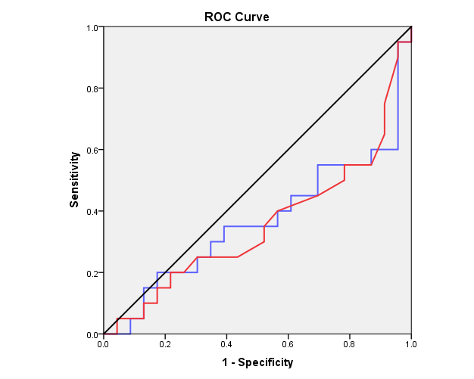
NLR (AUC: 0.365)
CRP (AUC: 0.354)
Reference line

Figure 1 Receiver operating characteristic curves of the NLR and CRP in predicting EOS in premature infants. Areas under the receiver operating characteristic (ROC) curves: NLR (blue line): 0.365 (95% confidence interval (CI): 0.192 to 0.538, P=0.131); the CRP level (red line): 0.354 (95% CI: 0.184 to 0.524, P=0.103).

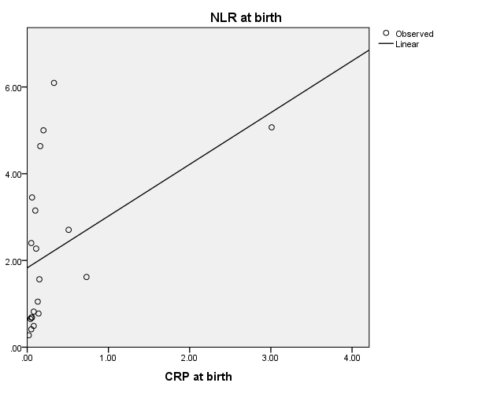
r= 0.702
p=0.001
Figure 2. Correlation of Neutrophil-to-lymphocyte ratio and C-reactive protein at birth among premature infants with EOS

