Cover letter

Bandung, May 3rd 2019

To:
Editor-in-Chief of Majalah Kedokteran Bandung (MKB)
in Bandung, Indonesia

Dear Sir/Madam,
We wish to submit an original research article entitled “The Effect Of Duration Of Preoperative Anti Tuberculosis Drug Administration On Tuberculosis Spondylitis Surgical Treatment Outcome” for consideration by Majalah Kedokteran Bandung.

We confirm that this work is original and that the manuscript has not been published elsewhere, nor is it currently under consideration for publication elsewhere. We also confirm that there is no falsification or fabrication of data and no plagiated content in the article.

We believe that this manuscript is appropriate for publication by Majalah Kedokteran Bandung because it will add the knowledge about management of spinal tuberculosis patient and there have been no studies that have examined the duration of administration of preoperative anti tuberculosis drugs. All authors of this manuscript have approved the final version of this submitted manuscript.

We have no conflicts of interest to disclose.

Thank you for your consideration of this manuscript.

Sincerely,

[Preodita Agradi, MD]

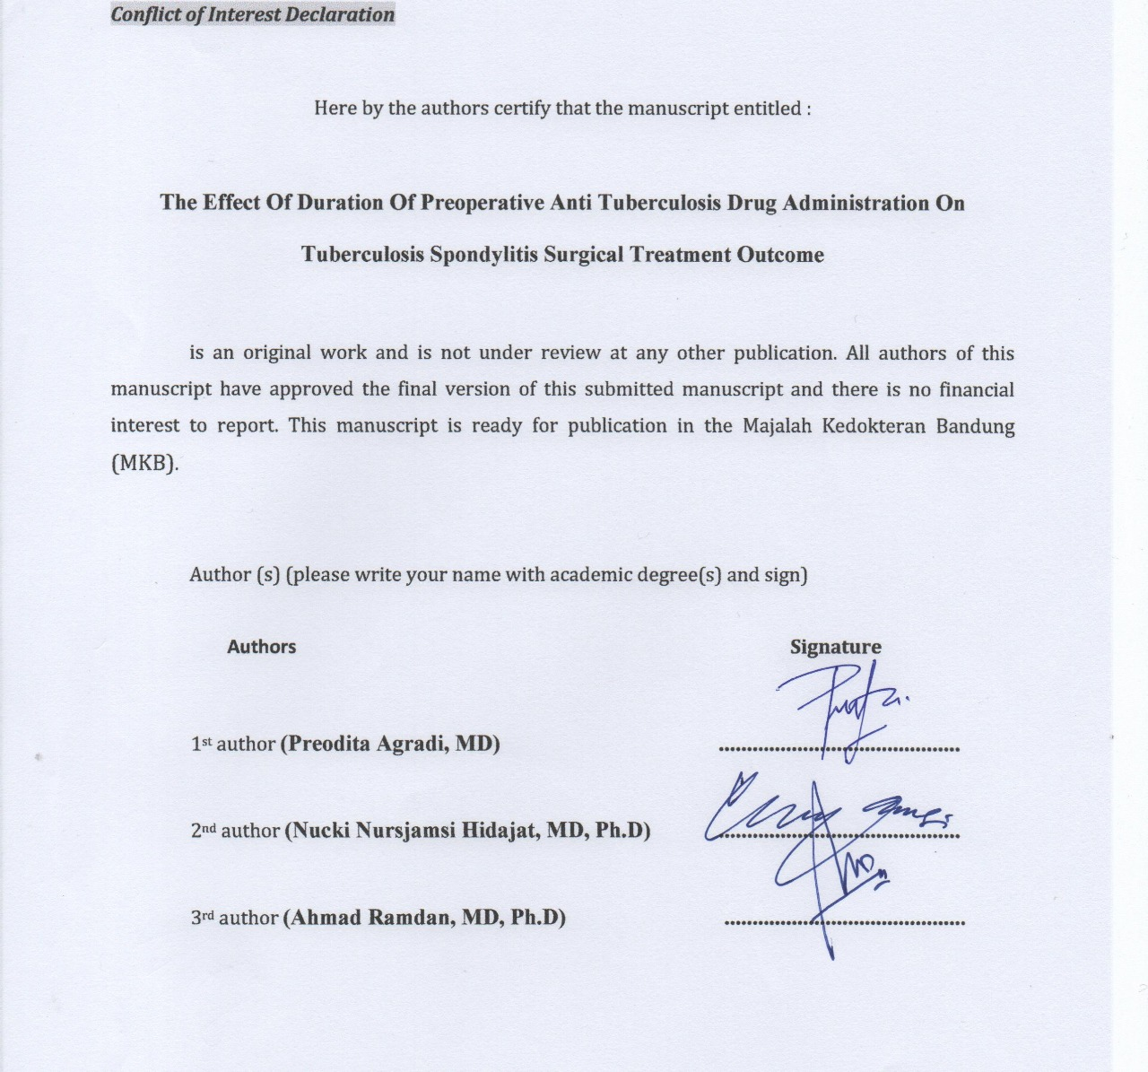
Conflict of Interest Declaration

Here by the authors certify that the manuscript entitled :

The Effect Of Duration Of Preoperative Anti Tuberculosis Drug Administration On Tuberculosis Spondylitis Surgical Treatment Outcome

is an original work and is not under review at any other publication. All authors of this manuscript have approved the final version of this submitted manuscript and there is no financial interest to report. This manuscript is ready for publication in the Majalah Kedokteran Bandung (MKB).

Author (s) (please write your name with academic degree(s) and sign)

Authors Signature

1st author (Preodita Agradi, MD) ...........................................

2nd author (Nucki Nursjamsi Hidajat, MD, Ph.D) ...........................................

3rd author (Ahmad Ramdan, MD, Ph.D) ...........................................

Author’s data

Title of manuscript:
The Effect Of Duration Of Preoperative Anti Tuberculosis Drug Administration On Tuberculosis Spondylitis Surgical Treatment Outcome

Enter the names of everyone who contributed to your manuscript by entering all required information.

Author(s)
1st author
First name : Preodita
Last name : Agradi
Academic degree(s): MD
Affiliation: Department Of Orthopaedic And Traumatology Faculty of Medicine, Universitas Padjadjaran, Hasan Sadikin General Hospital
Address: Jalan Pasteur No 38, Bandung, Jawa Barat, 40161
Phone: +62 812 25225443
Email: preodita@gmail.com

2nd author
First name: Nucki Nursjamsi
Last name : Hidajat
Academic degree(s): MD, Ph.D
Affiliation: Department Of Orthopaedic And Traumatology Faculty of Medicine, Universitas Padjadjaran, Hasan Sadikin General Hospital
Address: Jalan Pasteur No 38, Bandung, Jawa Barat, 40161
Phone: +62 22 2035477
Email: nuckinhidajat@gmail.com

3rd author
First name: Ahmad
Last name : Ramdan
Academic degree(s): MD, Ph.D
Affiliation: Department Of Orthopaedic And Traumatology Faculty of Medicine, Universitas Padjadjaran, Hasan Sadikin General Hospital
Address: Jalan Pasteur No 38, Bandung, Jawa Barat, 40161
Phone: +62 22 2035477
Email: ahmadramdan98@yahoo.com

Prospective Reviewer

I hereby suggest prospective reviewer(s) to Majalah Kedokteran Bandung (MKB) by filling in all required information:

Reviewer 1

Full name with academic degree(s):
Affiliation/institution:
Email:
Expertise:

Reviewer 2

Full name with academic degree(s):
Affiliation/institution:
Email:
Expertise:

Note: This is a tentative submission requirement to MKB. We kindly expect authors can suggest reviewer(s) who may come from different institution. If you find difficulty to meet the requirement, you can suggest only one reviewer. The suggested reviewer can be your lecturers, colleagues, and others who may potentially review your article. Thank you. (Please delete this note after filling in the form)

