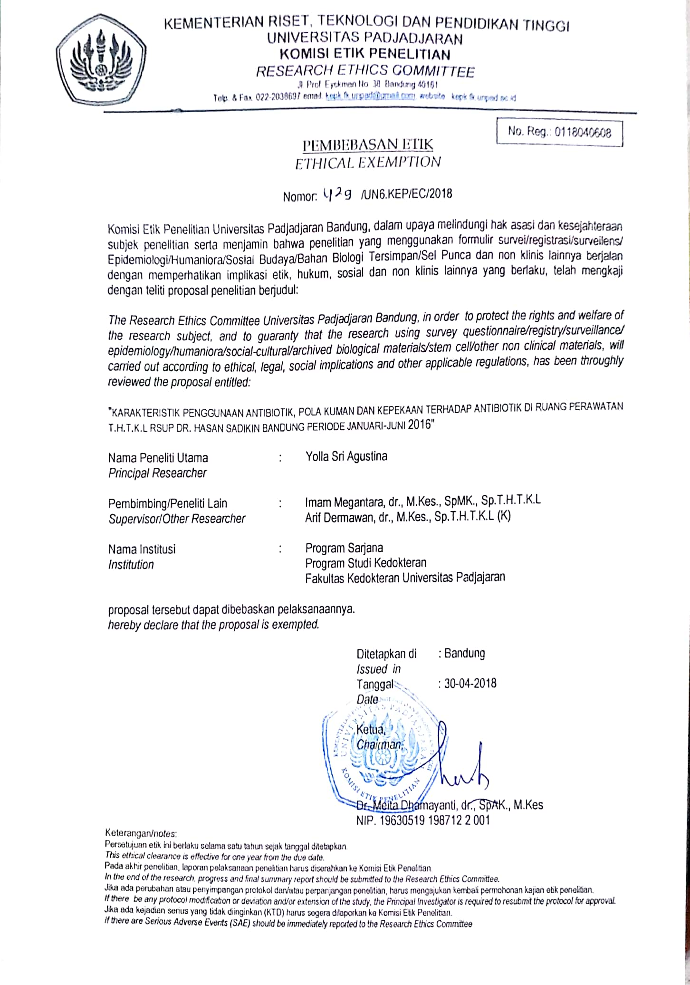
Appendix 1 Letter from Research Ethical Committee of Padjadjaran University, Bandung
Appendix 2. Letter from Medical Research Ethical Committee of Dr. Hasan Sadikin Hospital, Bandung
