The Hepatoprotective Effect of Trigona spp. Bee Propolis Against Carbon Tetrachloride-Induced Liver Injury in Rats

Rachel Amelia¹, Achadiyani², Begawan Bestari³

¹Faculty of Medicine, Universitas Padjajaran
²Departement of Cell Biology, Faculty Medicine, Universitas Padjajaran/Dr. Hasan Sadikin General Hospital, Bandung, Indonesia
³Departement of Internal Medicine, Faculty Medicine, Universitas Padjajaran/Dr. Hasan Sadikin General Hospital, Bandung, Indonesia

- Rachel Amelia
Faculty of Medicine, Universitas Padjajaran
Jalan Raya Bandung-Sumedang Km. 21
Jatinangor, Sumedang, West Java, Indonesia
Phone : +6281222475898
Email : rachel-rere@hotmail.com

- Dr. Achadiyani, dr., M.Kes
Department of Cell Biology, Faculty of Medicine, Universitas Padjajaran
Jalan Raya Bandung-Sumedang Km. 21
Jatinangor, Sumedang, West Java, Indonesia
Phone : +6281222102246
Email : achadiyani@gmail.com

- Dr. M. Begawan Bestari, dr., SpPD-KGEH, M.Kes, FASGE
Department of Internal Medicine, Faculty of Medicine, Universitas Padjajaran/ Dr. Hasan Sadikin General Hospital Bandung
Jalan Pasteur No. 38
Bandung, 40161, Indonesia
Phone : +62816629795
Email : begawan@gmail.com

The Hepatoprotective Effect of Trigona spp. Bee Propolis Against Carbon Tetrachloride-Induced Liver Injury in Rats

Rachel Amelia¹, Achadiyani², Begawan Bestari³

¹Faculty of Medicine, Universitas Padjajaran
²Departement of Cell Biology, Faculty Medicine, Universitas Padjajaran/Dr. Hasan Sadikin General Hospital, Bandung, Indonesia
³Departement of Internal Medicine, Faculty Medicine, Universitas Padjajaran/Dr. Hasan Sadikin General Hospital, Bandung, Indonesia

Abstract

Background: Oxidative stress reaction can cause liver injury. This process can be prevented by antioxidant activity which can break the destructive chain caused by free radical substances in the liver. Propolis produced by Trigona spp. bee is known to have high level of antioxidant is propolis. The aim of this study is to examine the effect of Trigona spp. bee propolis on liver histological toxicity caused by carbon tetrachloride-induced oxidative stress.
Methods: This experimental research was conducted in September 2013 in Animal Laboratory of Departement of Pharmacology and Therapy Dr. Hasan Sadikin General Hospital Bandung, Indonesia. Twenty four healthy male Wistar rats as objects were used with one week adaptation. The animals were divided into 3 groups randomly. Group I was control negative, group II was given carbon tetrachloride on day 14, group III was given Trigona spp. bee propolis on day 1 -14. On day 14,group III were injected CCl₄ intraperitoneally. After 24 hours of last treatment, all rats were sacrificed to get the liver tissue for histologic examination and the hepatocytes were counted as the average number of the normal cells. The quantitative data were statistically analyzed using One Way ANOVA and Tukey test with p value < 0.05.
Result: The average number of normal hepatocytes in treatment group was compared to control positive group and it showed the Trigona spp. bee propolis has protective effect.
Conclusion: Trigona spp. bee propolis has hepatoprotective effect against CCl₄-induced liver injury histologically.

Keywords: Carbontetrachloride, hepatoprotective, propolis, Trigona spp.

Efek Perlindungan Propolis Lebah Trigona spp. terhadap Kerusakan Jaringan Hati Tikus Akibat Induksi Karbon Tetraklorida

Abstrak

Latar Belakang: Reaksi stres oksidatif yang menyebabkan kerusakan jaringan hati dapat dicegah oleh aktivitas antioksidan. Propolis lebah Trigona spp. diketahui memiliki kadar antioksidan yang tinggi. Penelitian ditujukan untuk mengetahui efek propolis tersebut terhadap kerusakan jaringan hati akibat stres oksidatif melalui induksi karbon tetraklorida.
Metode: Percobaan ini menggunakan 24 ekor tikus jantan galur Wistar sehat yang dipelihara di Laboratorium Departemen Farmakologi dan Terapi Rumah Sakit Dr. Hasan Sadikin Bandung, Indonesia, bulan September 2013. Tikus diadaptasikan selama 1 minggu dan dibagi ke dalam tiga kelompok secara acak. Kelompok I adalah kontrol negatif, kelompok II diberikan karbon tetraklorida pada hari ke-14, kelompok III diberikan propolis lebah Trigona spp. pada hari ke 1–14. Pada hari ke-14, kelompok III diinjeksi CCl₄ secara intraperitoneal. Setelah 24 jam, seluruh tikus dikorbankan dan dibuat sediaan jaringan hatinya untuk pemeriksaan histologis, serta dilakukan perhitungan jumlah rata-rata hepatosit normal. Selanjutnya dilakukan uji analisis data kuantitatif menggunakan One Way ANOVA. (p<0.05).
Hasil: Jumlah rata-rata hepatosit normal kelompok III dibandingkan dengan kelompok II berbeda dan membuktikan propolis lebah Trigona spp. memiliki efek perlindungan terhadap kerusakan jaringan hati.
Simpulan: Propolis lebah Trigona spp. memiliki efek perlindungan terhadap kerusakan jaringan hati akibat induksi CCl₄ secara histologis.

Kata kunci: Efek perlindungan jaringan hati, karbon tetraklorida, propolis, Trigona sp.

Introduction
Hepatitis is still a serious health problem in Indonesia. According to Riset Kesehatan Dasar (Riskesdas) Nasional 2007, hepatitis was placed on the second cause of death.¹ On October 2007–2009, Ministry of Health Republic of Indonesia wrote about 17.999 positive hepatitis C cases. The liver destruction in hepatitis C has been known caused by oxidative stress mechanism.² Oxidative stress is a condition where there is a high level of free radicals; one of the potential substance is carbontetrachloride which has strong connection with pathologic process like cell destruction.³ Now, it is commonly used for inducing hepatitis model in experimental laboratorium animals. When carbon tetrachloride enter the body, this substance will be metabolized in the liver and will produce free radical such as trichloromethyl radical (CCl₃) and trichloromethyl peroxy radical (CCl₃O₂) that induce lipid peroxidation and death of the cell.⁴ One substance that can prevent lipid peroxidation is antioxidant. Propolis is a natural product, which is a mixture of resin and beeswax collected from plants particularly from flowers and leaf buds by honey bees (Apis spp. and Trigona spp.). It contains many chemical substance and varies depending on the plants resin geographically. The Trigona spp. bee found in many islands in Indonesia region and it has already studied that it has more antioxidant substance than propolis product by Apis mellifera.^{5, 6} Until now, there has been only few studies about its hepatoprotective effect.⁷ The objective of this study is to examine whether the Trigona spp. bee propolis has hepatoprotective effect against oxidative stress mechanism, so after further preclinical and clinical studies has been done, it is hoped that this propolis can be effectively used by hepatitis high risk patient and also the patient with chronic hepatitis.

Methods
This experimental research was done in animal laboratory of Pharmocology Department Dr. Hasan Sadikin General Hospital, Bandung, Indonesia, on September 2013. Twenty four healthy male Wistar rats as objects were used.⁴ All laboratory experimental animal in this study was approved by Ethical Clearance Comittee. The animals were divided into 3 groups randomly and given standard food and water. This research was done in fifteen days excluded from one week of adaptation. Group I was control negative, which given standard food and water. Group II was control positive which was given 1ml/kgBW CCl₄ 50% intraperitoneally at day 14 to induce necrosis of hepatocytes.⁸ Group III was given Trigona spp. propolis on day 1–14 and on day 14, 3 hours after given propolis, the rats were injected by 1 ml/kgBW CCl₄ 50% intraperitoneally.⁹ After 24 hours of last treatment, all rats from all groups were sacrified. First the animals were anaesthetized using ketamine intramuscularly and then laparotomy was done to expose the liver organ. After that, the liver was perfused using NaCl 0.9% through left ventricle, and blood was cleared from the body through inferior vena cava. Liver also washed by formalin 10% then excised and transferred to a 10% formalin fixative solution. The liver tissues were processed for paraffin embedding and sections (5 µm thick) were taken in a microtome. After staining with hematoxylin and eosin, slides were examined under microscope (400x) for histopathological changes and counted the average of the normal cells in each group. The quantitative data were statistically analyzed using One Way Analysis of Varian (ANOVA) followed by Tukey test using Statistical Product and Service Solutions (SPSS) for windows version 13.0. A p-value of less than 0.05 was considered as statistically significant.

Result

Table The Average Number of Normal Hepatocyte from Each Group
Group | Number of Normal Hepatocyte  (mean±SD) | p *
Group I | 463.50±9.59281 | 0.00
Group II | 146.07±7.56885 | 0.00
Group III | 263.24±14.10860 | 0.00
p* = one way ANOVA

The data analyzed by one way ANOVA statistical test showed p = 0.00 and it means the difference of average number of normal hepatocytes between group was significant. The Tukey test also shows the difference of the average number of normal hepatocytes between groups are significant one by another. The result from group I was the liver showing normal cells, where no significant injury of the membrane, round and complete nucleus. The average number of liver cell in this group was 464 ± 9.59281 cells / field (Figure 1); group II underwent necrosis and the average of the cells was 146 ± 7.56885 cells / field (Figure 2) ; group III showed some normal liver cells, and some necrotic area with the normal liver cells average was 263 ± 14.10860 cells / field (Figure 3).

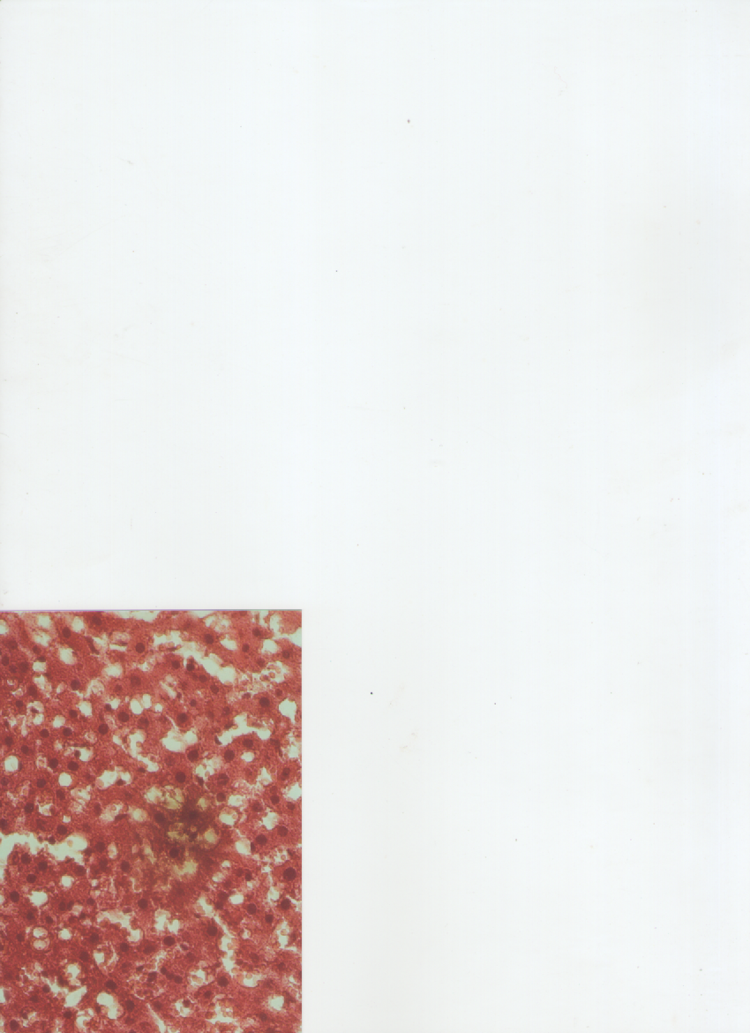

H

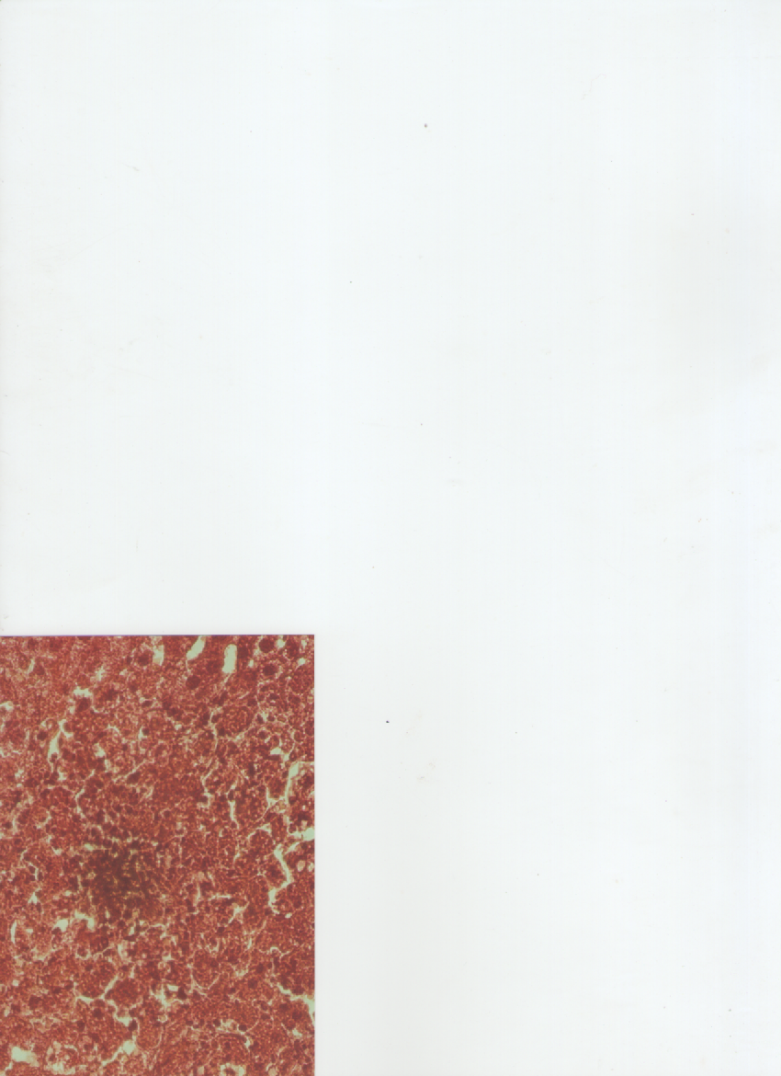
Figure 1 The Liver Histologic View from Group I

N
H

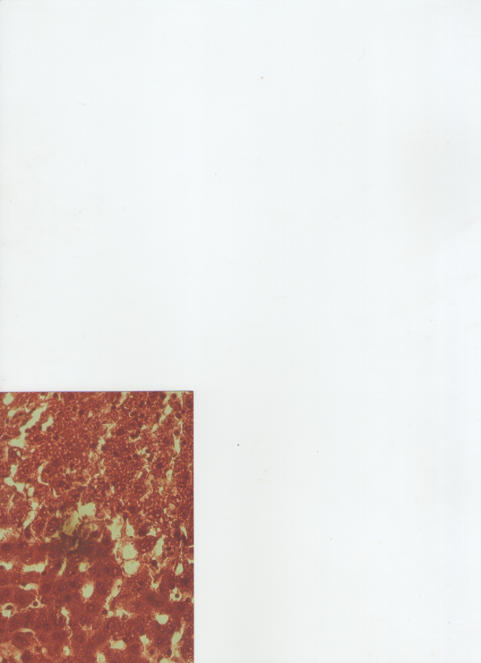
Figure 2 The Liver Histologic View from Group II

H
N

Figure 3. The Liver Histologic View from Group III
Note: H=normal hepatocyte, N=necrotic area

Discussion

Effect of CCl₄ in 24 hour acute exposure in control positive group was marked by the existence of necrotic area on hepatocytes, characterized by rupture of cell membrane, vacuolization of the cytoplasm, karyolisis, pyknosis, and karyorrhexis. This findings are further supported by earlier reports by Girish et al., that CCl₄ produced various histological changes in the hepatocytes after 24 hours of administration.^{8, 9} The analytic studies of the average number of normal hepatocytes showed the difference between control negative and control positive group were different significantly (p=0.00). We could conclude that CCl₄ that was given to the group II made significant injury to the liver cell. This process began from CCl₄ turned into CCl₃ and reacted with the oxygen forming more reactive substance; CCl₃O₂ and then it reacted with membrane cell phospholipid and initiated an extensive intrahepatic peroxidation reaction chain. In the end, there was necrosis of the hepatocytes.⁴
Group III had more normal hepatocytes compared to group II. The data was significant after analyzed statistically. The protective effect of this propolis was about 37%. According to C. Chanchao et al.¹⁰, the propolis itself was non-toxic to the normal cells. Condition of oxidative stress establish due to insufficient defense capacities against reactive oxygen species (ROS). The ROS also affect antioxidant defense mechanism, and reduce intracellular concentration of antioxidant produced by the body. Although our body has its own antioxidant and regulation to this substance capacity physiologically, other source of antioxidant is important as well for scavenging free radicals that formed in the body. Propolis consists more than 300 different compounds including flavonoids, phenolics, wax, vitamins, and minerals.⁵ It has been proved that bees do not change its chemical composition. In propolis, the major antioxidant is flavonoids. It could give protection to the liver cells by decreasing formation of CCl₃ and CCl₃O_{2.}¹¹ It is already studied that Trigona spp. bee propolis has high level of antioxidant, especially flavonoid 4% which is higher than in another propolis that is produced by Apis mellifera bee is 1.5%.^{5, 6} Besides, the propolis contains another substance that is known for its antioxidant and antiinflammatory activities such as caffeic acid phenethyl ester (CAPE) where it showed a free radical scavenging effect.¹²
From the result above, the conclusion is Trigona spp. bee propolis has hepatoprotective effect against CCl₄-induced liver injury in male Wistar rats histopathologically.

Referrences

1. Kementerian Kesehatan Republik Indonesia. Masyarakat Dunia Peringati Hari Hepatitis. [cited 28 Juli 2010]. Available from: www.depkes.go.id/index.php?vw=2&id=1156.

2. Muriel P. Role of free radicals in liver diseases. Hepatol Int. 2009;3(4):526–36.

3. Kumar V, K.Abbas A, Fausto N, Aster JC. Cellular Responses to Stress and Toxic Insults: Adaptation, Injury, and Death. In: Schmitt W, Gruliow R, editors. Robbins and Cotran Pathologic Basis of Disease. 7th ed. Philadelphia: Elsevier Saunders; 2010. p. 20–2.

4. U.S Environmental Protection Agency Washington D. Toxicological review of carbon tetrachloride. Washington DC: United States Environmental Protection Agency; 2010.

5. Surendra NS, Bhushanam M, Ravikumar H. Antimicrobial Activity of Propolis of Trigona sp. and Apis mellifera of Karnataka, India. Prime Journal of Microbiology Research. 2012;2(2):80–5.

6. Mahani, Karim R, Nurjanah N. Keajaiban propolis trigona. Jakarta: Pustaka Bunda Grup Puspa Swara; 2011.

7. Umthong S, Puthong† S, Chanchao C. Trigona laeviceps Propolis from Thailand: antimicrobial, antiproliferative and cytotoxic activities. Am J Chin Med. 2009;37(05):855–65.

8. Girish C, Koner BC, Jayanthi S, Rao KR, Rajesh B, Pradhan SC. Hepatoprotective activity of six polyherbal formulation in CCl₄-induced liver toxicity in mice. Indian J Exp Biol. 2009;47(4):257–63.

9. Xu J-Y, Su Y-Y, Cheng H-S, li S-X, Liu R, Li W-X, et al. Protective effects of fullerenol on carbon tetrachloride-induced acute hepatotoxicity and nephrotoxicity in rats. Carbon. 2010;48(5):1388–96.

10. Chanchao C, Umthong S, Phuwapraisirisan P, Puthong S. Trigona laeviceps propolis : chemical compositions and antiproliferative activity on cancer cell lines. Planta Med. 2011;77:49.

11. Shukla S, Bhadauria M, Jadon A. Effect of propolis extract on acute carbon tetrachloride induce hepatotoxicity. Indian J Exp Biol. 2004;42(10):993–7.

12. Wu W-M, Lu L, Long Y, Wang T, Liu L, Chen Q, et al. Free radical scavenging and antioxidative activities of caffeic acid phenetyl ester (CAPE) and its related compounds in solution and membranes: a structure-activity insight. Food Chem. 2007;105(1):107–15.

