LETTER OF DECLARATION

To:
Editor-in-chief
Althea Medical Journal (AMJ)

With this letter we declare that:

Title of article: Relationships of Vascular Endothelial Growth Factor Expression with Juvenile Nasopharyngeal Angiofibroma Stage

Author : 1. Ifiq Budiyan Nazar
2. Yussy Afriani Dewi
3. Agung Dinasti Permana
Focus and scope : Oncology and Otorhinolaryngology Head and Neck Surgery
has been approved by the co-author/s to be published in Althea Medical Journal (AMJ), does not contain plagiarism as a whole or in parts, and is not currently being submitted/ processed in other journals.

Bandung, Octobre, 27, 2020
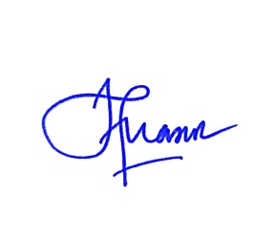
Authors Signatures

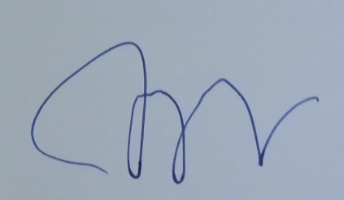
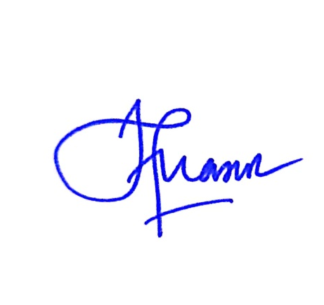
dr. Ifiq Budiyan Nazar .............. .......................
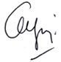

Dr. dr. Yussy Afriani Dewi, Sp.T.H.T.K.L(K)., M.Kes., FICS .............. .......................
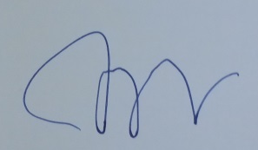

Dr. dr. Agung Dinasti Permana, Sp.T.H.T.K.L(K)., M.Kes ..................................

